Free Your Mind --- NOT a Tin Foil Hat
Visual Thinking, Spring 2012, North Seattle, M. Kelly
Sculpture Project 2 – Due: Monday May 21
Meet Your Clients Needs

Each of your clients has been part of a secret research project that has confirmed that aliens have infiltrated our brains and are influencing our thoughts. It has now become imperative that they shield themselves from these destructive influences.
You have been hired to design a garment that will protect these individuals from this devastating force. Humanity once mistakenly thought this was an imaginary threat and made metal foil hats as a gag to pretend they were protecting against this problem. It is no longer a joke, the threat is real.
The research has revealed that foil will not work. (see examples below) Do NOT use foil to create this item.
 This could work.
No other restrictions apply. Perhaps just protecting the brain will be enough, or adequate protection may require a full body hazard garment. Your client is depending on your unique expertise to decide what is necessary and expect the garment to suit her or his culture, style and personality.
They are depending on you. Do not fail!

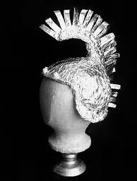


These will not.

In order to evaluate which products best meet their needs, your clients would like a written synopsis including:
- A description of the client that you have developed through your research, including the photo. As is said in “Objectified” design starts with people. What is the client’s story? What gives their life meaning? If they had 20 minutes to get out of a building, what would they take into their future?You will create the clients “personal profile” based on this photo and discuss it in this description.)
- How well the product meets the clients aesthetic requirements. Keep in mind their culture, interests, style and individual personality.
- How well the product functions, please describe how and why your product will protect the client from alien influences.
How well your product is rated will be based on the product and this keyboarded, double spaced prospectus you write for the client.

